Maven assignment

1. Creating a Maven java project with below information

groupId : com.assignment

artifact Id : my-assignment version

version :<anything>

packaging : Jar

ArchetypeArtifactId : maven-archetype-quick start

1. Run the following command and observe the execution and capture the outcome.
2. mvn clean

b. mvn compile

c. mvn test

d. mvn package

e. mvn install

f. mvn clean package

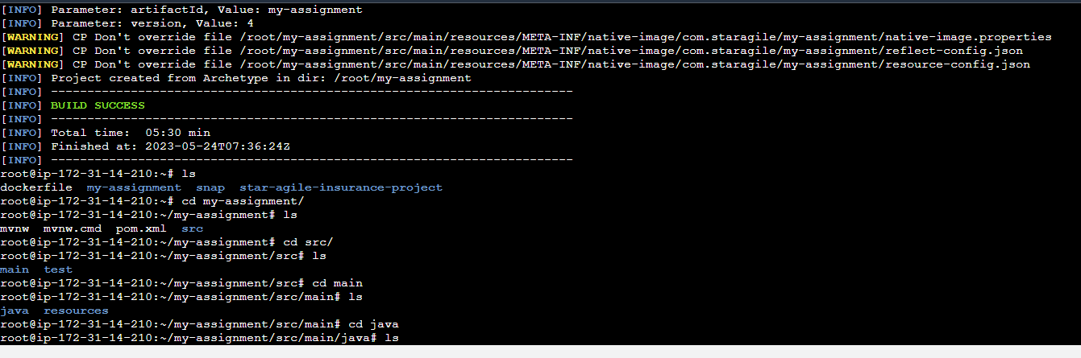

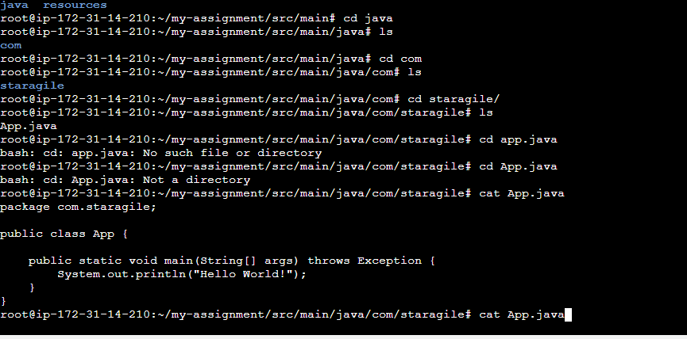

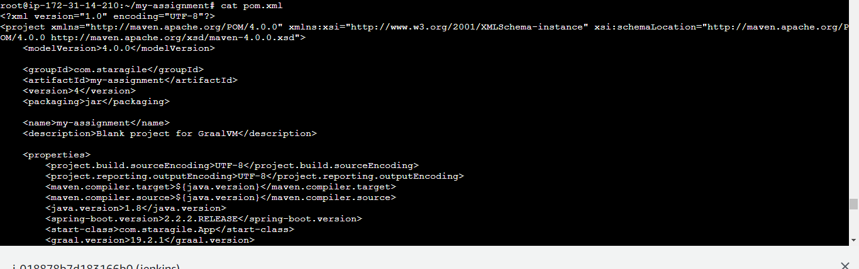

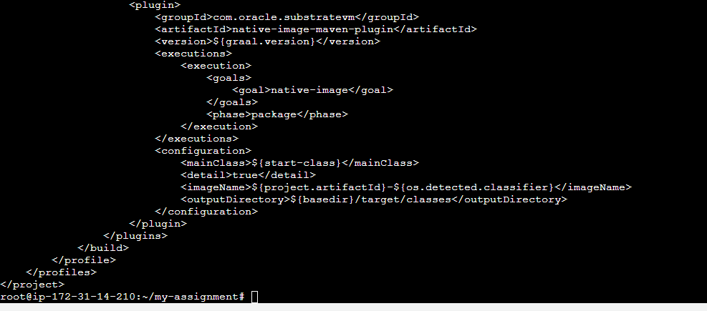

1. mvn clean

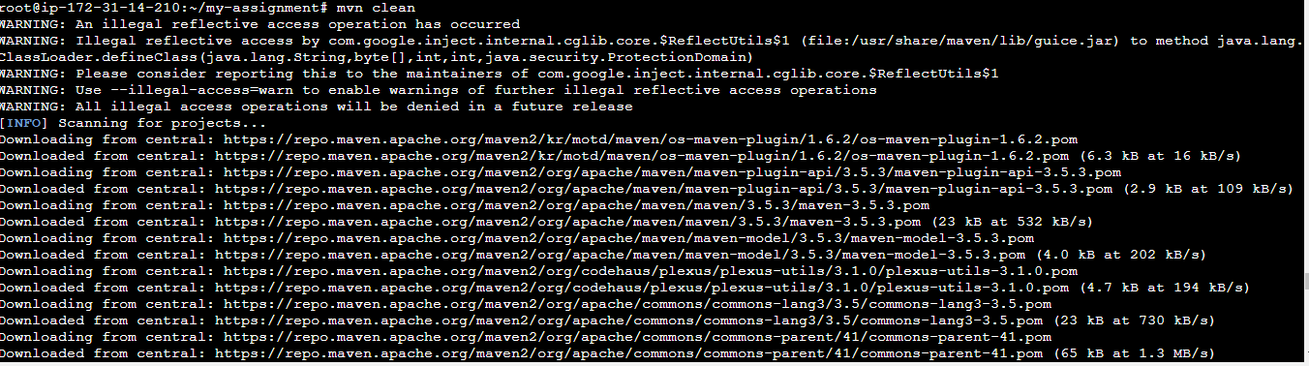

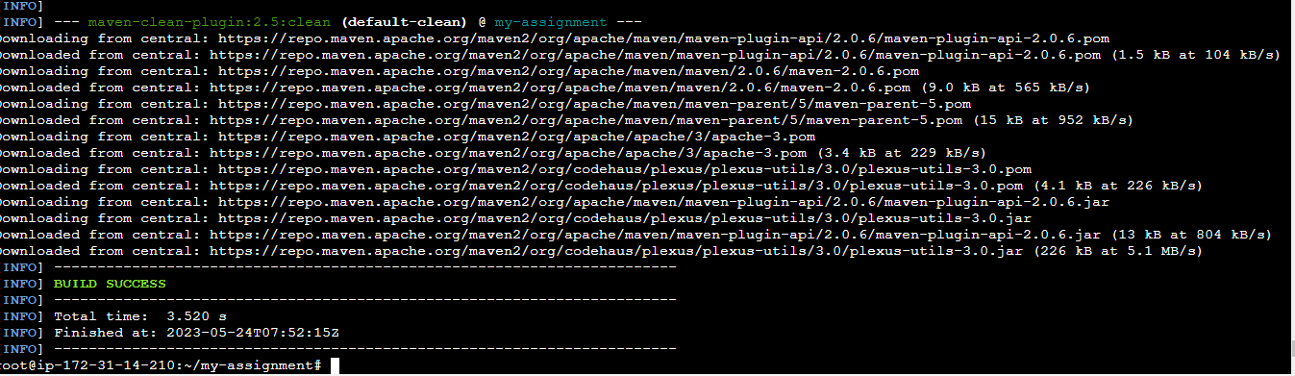

1. mvn compile

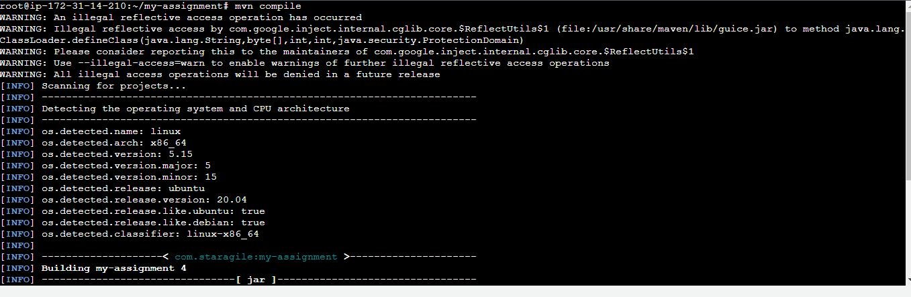

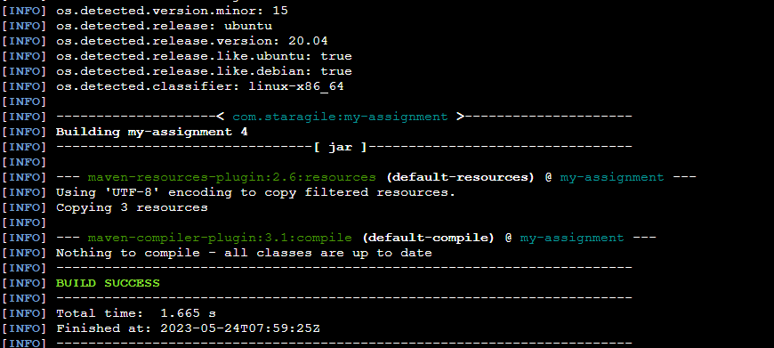

1. mvn test

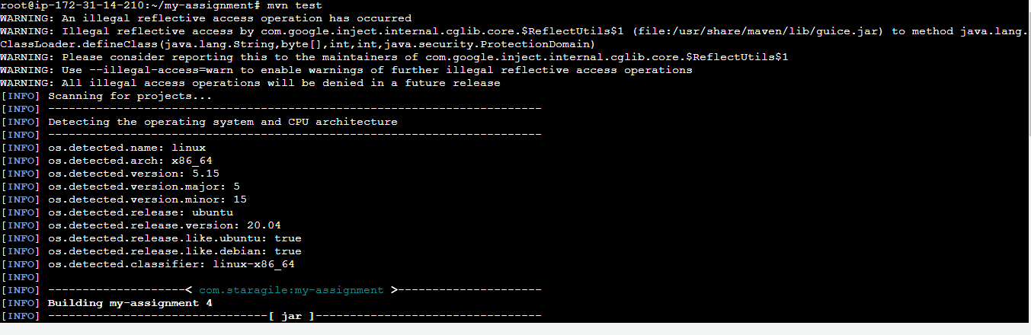

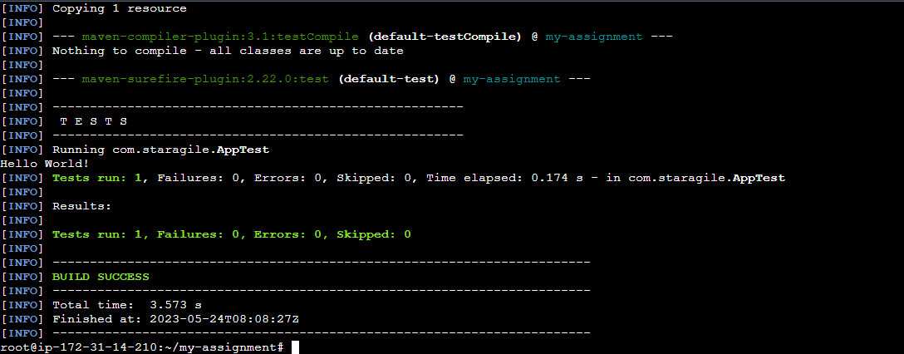

Mvn package

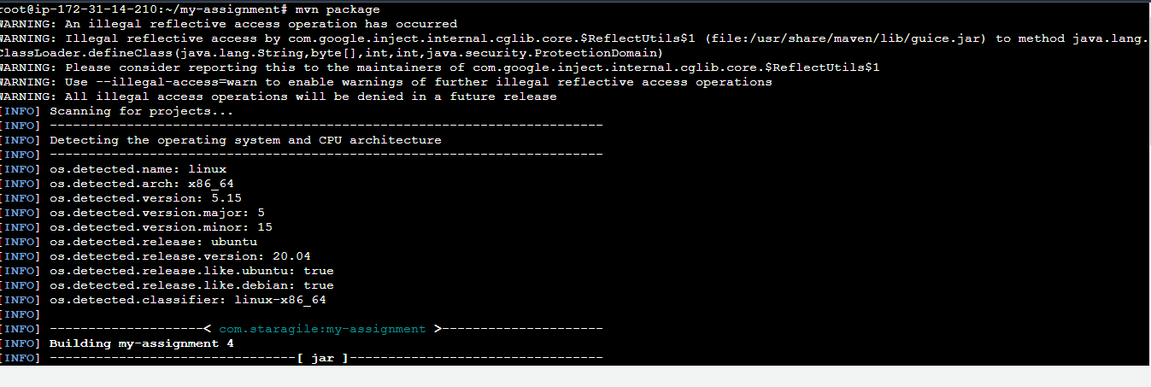

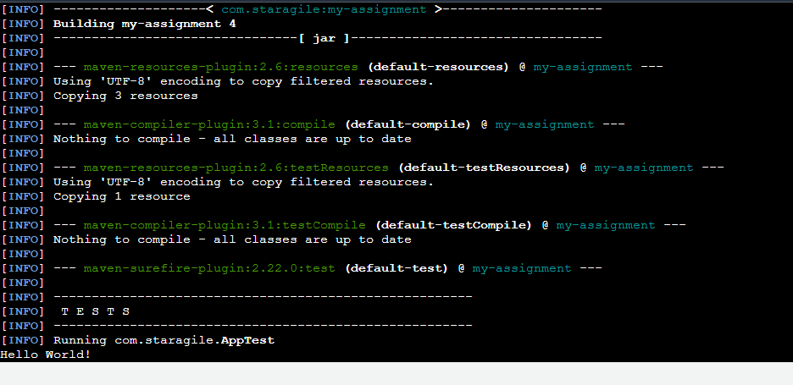

mvn install

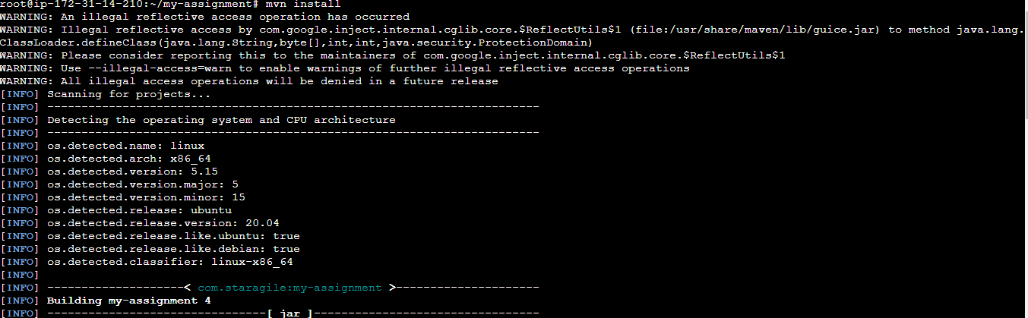

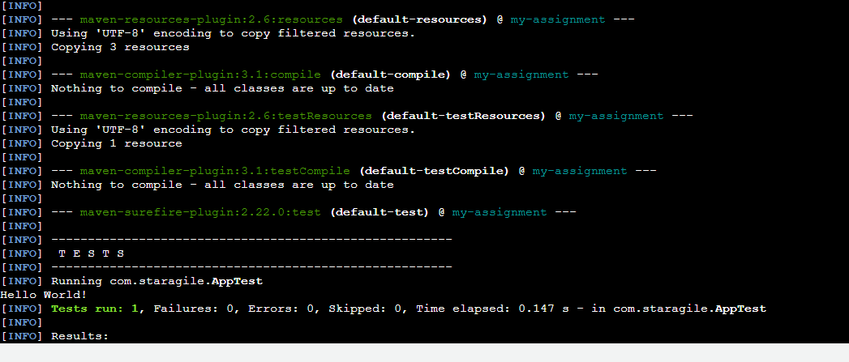

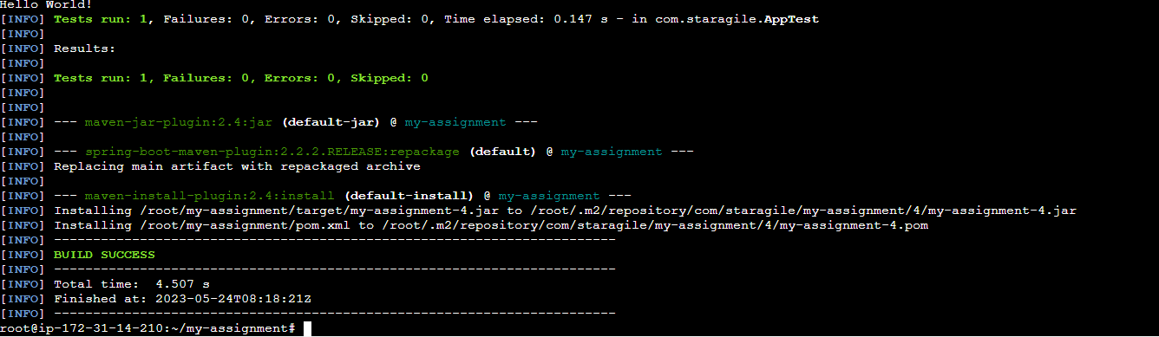

Mvn clean package

